# User manual

This movie is about two snipers, who try to eliminate the two watching guards. Afterwards a group of soldiers invade the village.  
  
As default, the movie flies in an animated camera flight through the fighting scenes. By typing any key the animated camera flight is interrupted. After it is interrupted, you can move through the scenes by using the keys w,a,s,d and the mouse. When you (the camera) get within the radius of a scene (e.g. snipers), then these events are triggered.

**Scene 1:**

The first scene is about the two snipers, who crawl on a hill to eliminate the two guards on the watching towers. In this scene you can see the heightmap (in all scenes), object transformations and particle systems (smoke of the gun and bonfire).

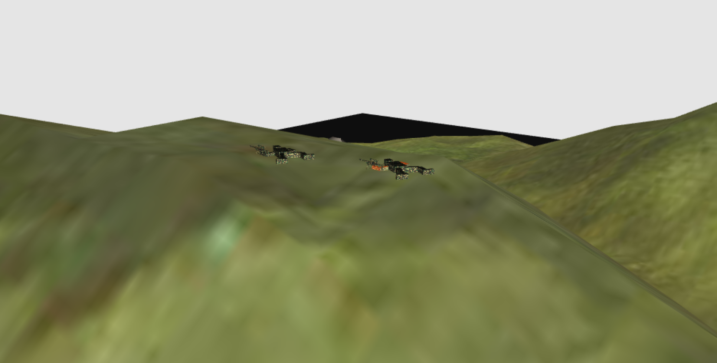

**Scene 2:**

In the second scene you see the enemy village with the two dead guards on the watching towers, one guard who is patrolling in front of the village and also the bonfire (particle system).

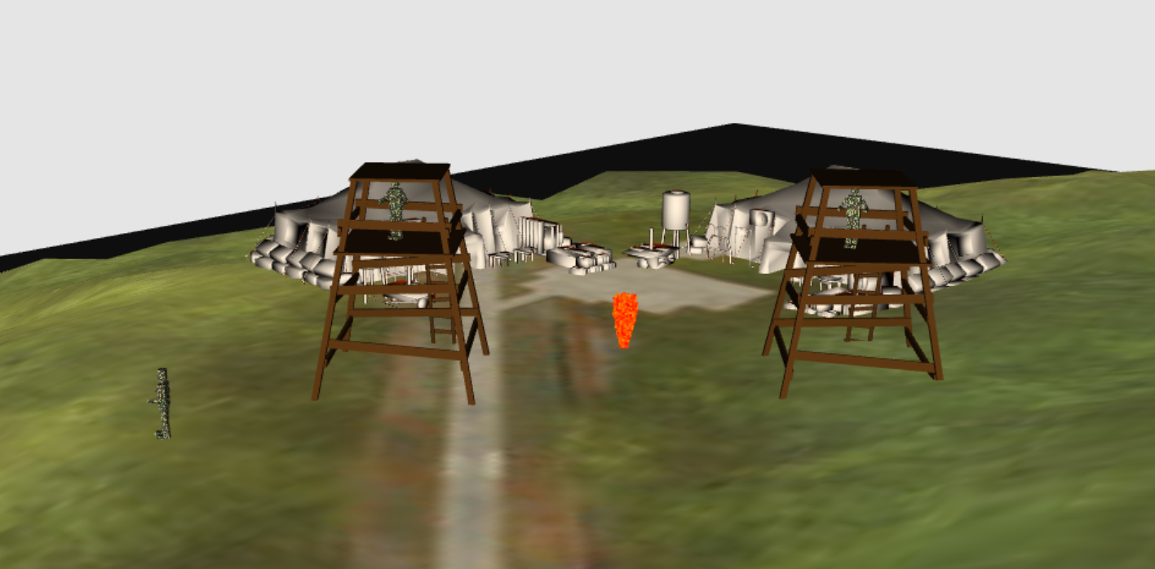

**Scene 3:**

The third scene is about the group of soldiers, which is invading the village.

